**FILTERING REQUIREMENTS**

Click on filter icon then select filter/sort

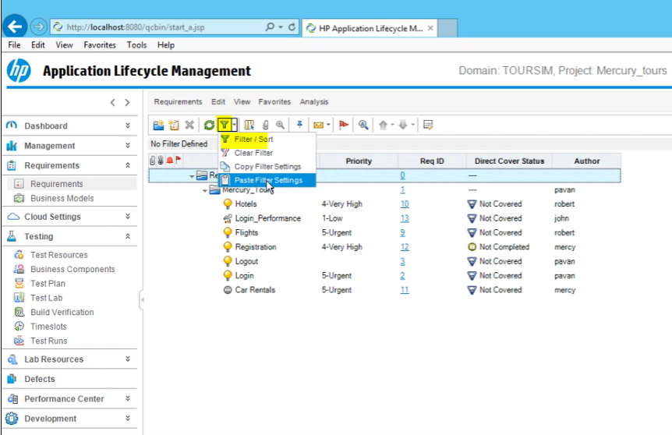

From the window select your filter

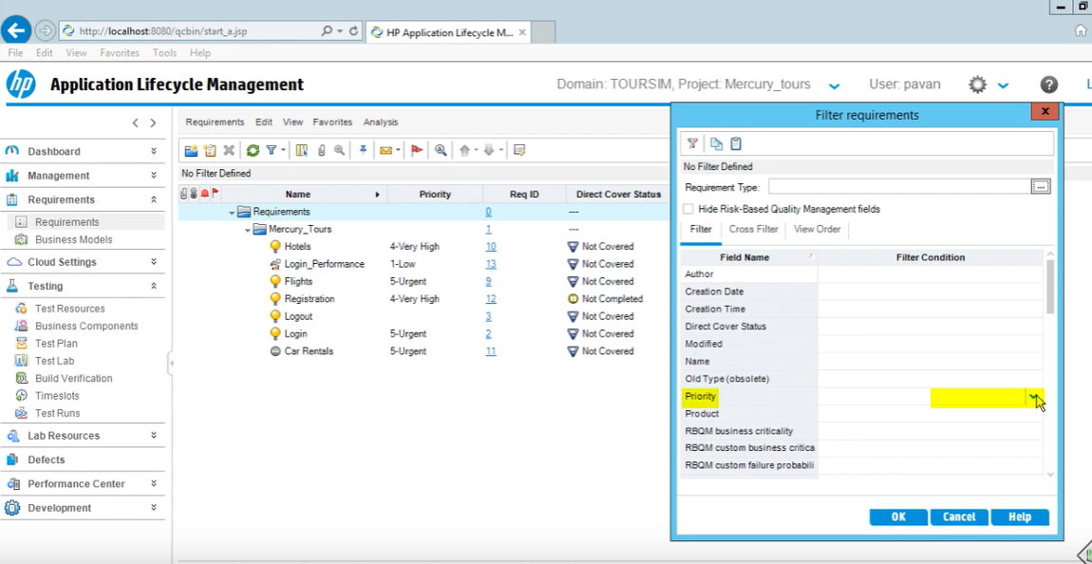

Click OK

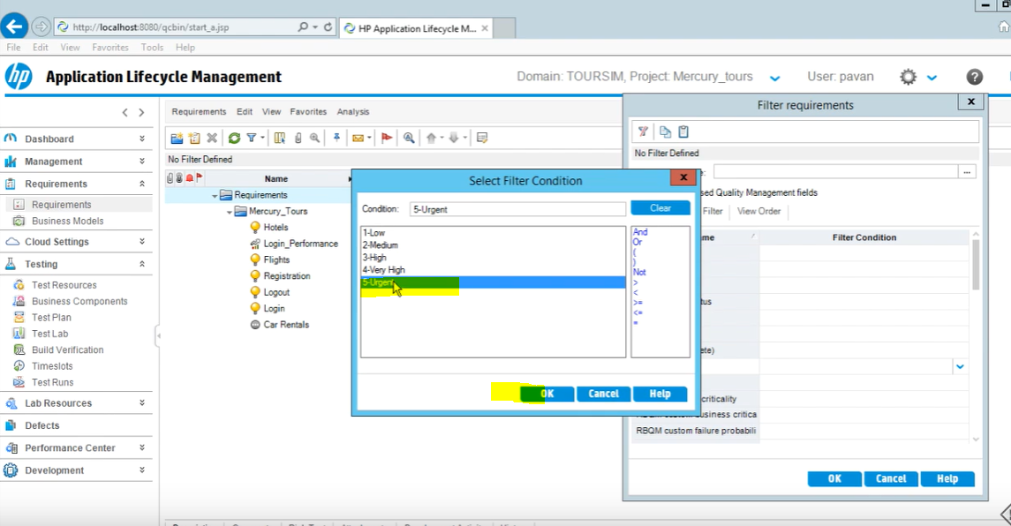

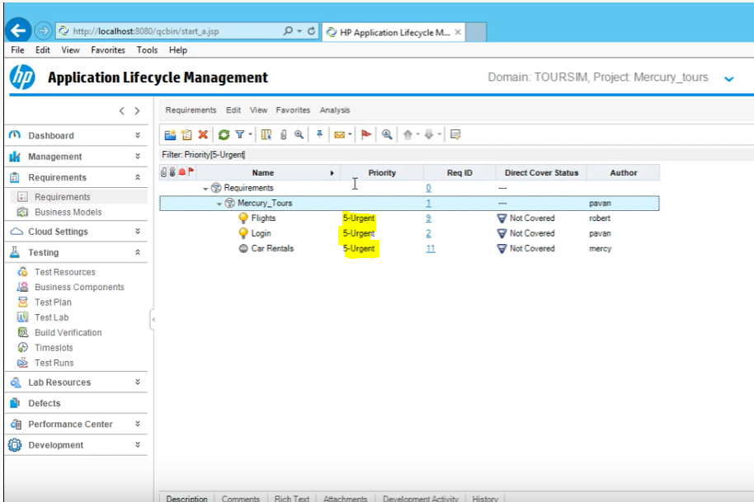

You can also select more than one filter

First select Urgent then, click on “Or” then, select Very High

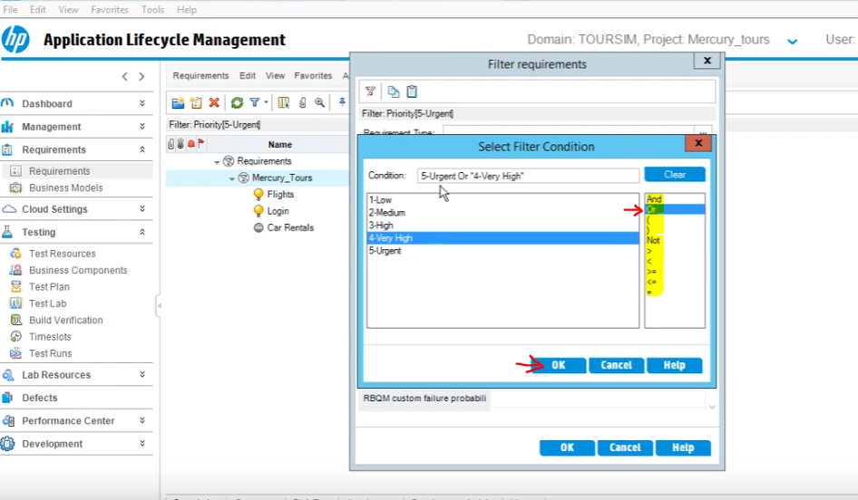

Then Click OK

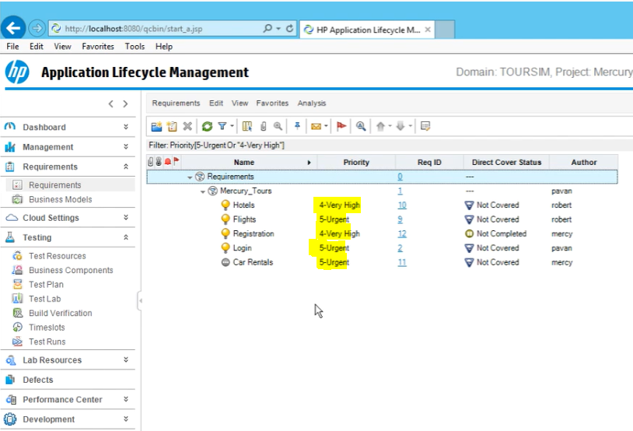

You can also select more the one type of filter

Such as Requirement “Very High” or “Urgent” Priority also Author “Pavan”

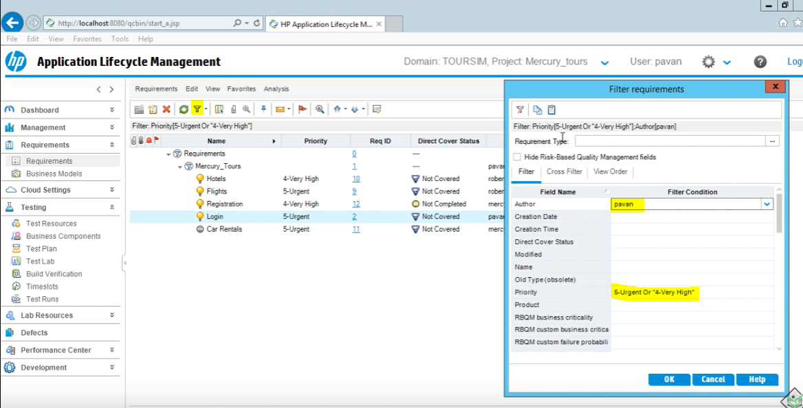

Click OK

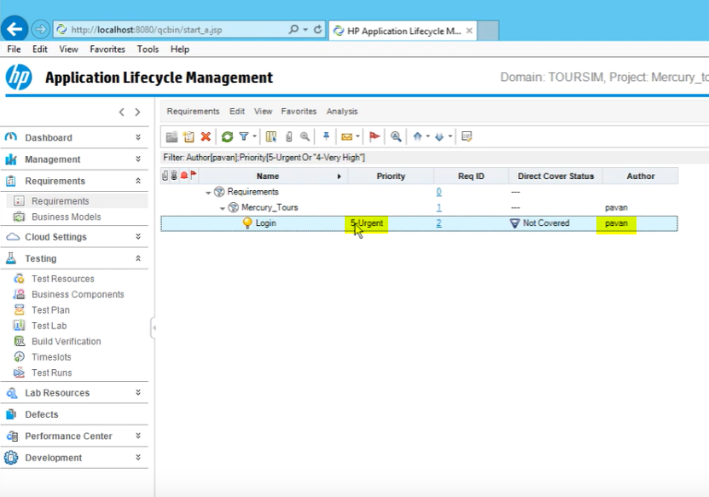

You can clear the filters later

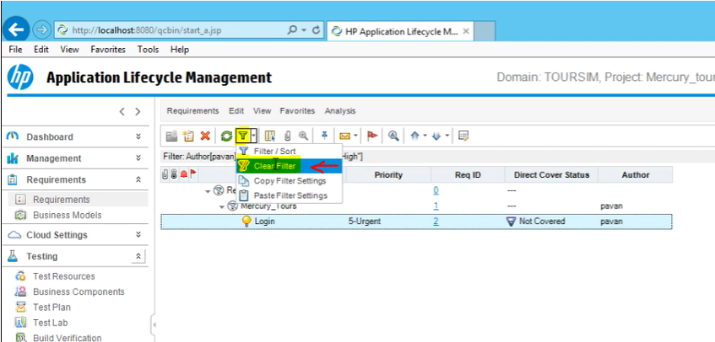

Always Make Sure it says “No Filters Defined”

